附件：学术论文参考范文

Analysis of Groundwater Contamination and Countermeasures in Jiaozhou Bay

**Abstract:** As the “mother bay” of Tsingtao, Jiaozhou Bay largely promotes the local economy development and provides a firm backup for both local industry and agriculture. (研究背景及意义) **However**, due to excessive human activities, the water environment has drastically degenerated, causing severe ecological problems and hindering human production activities.(现状) **In order to summarize** the causes of groundwater contamination and its control measures, (研究目的)this paper **explores the monitoring data and the numeral analysis of groundwater quality in Jiaozhou bay**,(研究方法)which **demonstrate** that the biggest contributing factors of contamination are the overuse of fertilizers, pesticides, and the emission of industrial wastewater.(研究结论) Local government **deals with the problem by** investigating and regulating the sources of contamination, improving the polluted water. And Jiaozhou Bay groundwater quality has been significantly improved. (解决办法)

**Key words:** Environment; Groundwater Contamination; Countermeasures

**Introduction**

In a narrow sense, Jiaozhou Bay, as a natural semi-closed inlet of Yellow Sea, is an antifreeze deep water port of China, the length 18 sea miles, the width 15 sea miles and depth 10 to 15 meters. In a general sense, it is located on the southern coast of the Shandong Peninsula in East China, and separates Huangdao from Tsingtao City and borders on Jiaozhou city. In this paper, the research object is Jiaozhou Bay in general sense. There are altogether 11 rivers in Jiaozhou Bay, which are divided into three major parts: Dagu River basin, North Jiaolai River basin and Coastal basin. Among them, the larger rivers flowing into Jiaozhou Bay are the Dagu River, the Ink River, and the Baisha River.

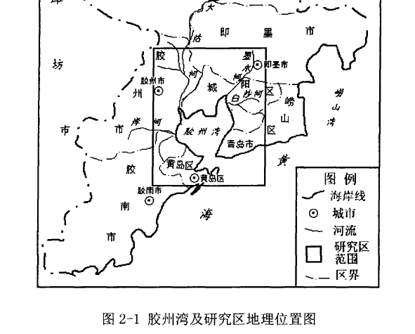

Figure1 Map of Jiaozhou Bay and Research Location

As the “mother bay” of Tsingtao, Jiaozhou Bay largely promotes the local economy development and provides a firm backup for both local industry and agriculture with its affluent amount of water resources. However, due to excessive human activities, the water environment has drastically degenerated, causing severe ecological problems and hindering human production activities.

**Literature Review**

Since groundwater contamination and countermeasures are such a large issue that influences sustainable development, scholars have done a large scale of researches. Yuling Ye’s research (2006) focused on the increasing tendency of nutrients quantity in Jiaozhou Bay, which was closely related to the increasing number of Nitrogen and Phosphorus entering into the seawater from the groundwater. Zhiliang Shen (2002) made a similar research regarding seawater contamination and its influences in Jiaozhou Bay. By contrast, foreign scholars pay more attention to the assessment of groundwater quality. St.C.Michaelido (1995) used combined biological and chemical methods to investigate groundwater contamination. Up to this time, the research on groundwater contamination are intensified by Chinese scholars, however, the research on groundwater contamination in Jiaozhou Bay over the past several decades were far from perfect. The former scholars did not have a comprehensive survey.

**Materials and Methods**

Taking Jiaozhou Bay as the research object, this paper has collected a lot of literature data, especially the hydrogeological survey of Jiaozhou Bay area, the interannual variation data of groundwater nutrient content, and also collected the measures taken by the government to deal with this phenomenon and its effectiveness.

The quality of groundwater is divided into five categories. Water in Class I and II has good water quality, are suitable for all kinds of usage. Water in Class III and IV, after proper disposal, can be used as domestic drinking water. Water in Class V can only be used as agricultural and industrial water but cannot be used as domestic drinking water anymore. In the water quality standard report of China GBT14848 - 93, the nitrogen content in groundwater exceeds 30mg / l, that is, water in class V. In other words, the nitrate content in groundwater exceeds 132.7 mg / l, that is water in Class V. Meanwhile, when the chloride content is more than 350 mg / l, it also belongs to Class V water.

|  |  |  |  |  |  |  |
| --- | --- | --- | --- | --- | --- | --- |
| 9 | Chloride(mg/L) | ≤50 | ≤150 | ≤250 | ≤350 | >350 |
| 10 | Nitrogen(mg/L) | ≤2.0 | ≤5.0 | ≤20 | ≤30 | >30 |

It was observed that during 1980s-1990s, the content of chloride and nitrate in groundwater gradually increased. In 1991-2001, in the observation points of the Dagu River, the nitrate concentration in the upper section (above the PingduRenzhao districts) was as high as 200mg / l, in the middle section (PingduRenzhao-Jiaozhou Ligezhuang districts), the nitrate concentration was as high as 150mg / l, and in the lower section (districts below Jiaozhou Ligozhuang), the nitrate concentration was above 200mg/l. They were far beyond 132.7 mg / l, which belong to Class V water. In the Baisha River and the Ink River basins, the nitrate content in Chen Ancient Town was as high as 400 mg / l. The chloride content in some areas of Dagu River basin was more than 400 mg / l. In the offshore part of Baisha River and Ink River basins, it was as high as 650 mg / l.

It can be concluded that during 1980s-1990s, groundwater quality in Jiaozhou Bay area was poor which meant the groundwater was severely contaminated. From the 1970s to the 1980s, the groundwater table in the Dagu River basin was generally higher than the river. However, because of the over-exploitation of groundwater by human beings, the groundwater table gradually dropped, and the river recharged the groundwater, which brought a large amount of nitrate to the groundwater and became the main cause of groundwater contamination. At the same time, due to the lowering of groundwater table, the seawater in Jiaozhou Bay region entered into the groundwater, resulting in an intrusion of salt water, which made the chloride content in groundwater increase continuously, resulting in contamination.

Since the 1990s, with the decrease of human exploitation of groundwater and the increase of atmospheric precipitation, the groundwater table was gradually rising, but the pollution situation was not improved. The polluted groundwater was transported to the sea water, which made the nitrogen element in Jiaozhou Bay sea area increase sharply. The eutrophication of seawater caused a large area of red tide events, which had a serious impact on marine ecology and human production activities.

Since the beginning of the 20th century, the Tsingtao Municipal Government has attached great importance to groundwater contamination thus invested a great deal of financial and material resources to control it. The government adopted various measures, such as expanding and renovating sewage treatment plants, cleaning up river silt refuse, taking ecological compensation implementation on the Dagu River. A great breakthrough progress was made on the groundwater management in 2015.

The environmental protection department of Tsingtao conducted an investigation on the groundwater quality of the whole city. Concerning groundwater quality and safety, the conventional pollutants, organic pollutants and highly toxic chemicals in the groundwater drinking water sources were investigated by the department. In addition, a comprehensive survey on the main chemical enterprises which might have groundwater safety risks were also carried out. Meanwhile, by using satellite remote sensing technology, the location and distribution of municipal solid waste landfills were determined, and the environmental monitoring archives of underground water in municipal solid waste landfills were established. As of today, Jiaozhou Bay groundwater quality has been significantly improved.

**Results**

As is shown in the research, it can be found that there is an acute deterioration of the groundwater quality of Jiaozhou Bay in 1970s-1990s. Two main reasons are attributed to this phenomenon. On the one hand, the liquid waste from urban zone and industrial zone discharging into rivers and usage of agrochemical such as pesticides and fertilizers severely polluted the rivers, which would recharge groundwater and caused the deterioration of groundwater. On the other hand, over exploitation of groundwater led to a decline of the groundwater table, causing seawater intrusion. A large amount of sodions and chloridions entered into the body of the groundwater, leaving it polluted. Fortunately, Tstingtao government paid high attention to groundwater contamination in Jiaozhou Bay; meanwhile it took appropriate countermeasures. Remarkable results have been achieved with the improvement of groundwater quality.

**References**

[1]St.C. Michaelidou, Investigating Groundwater Pollution from Different Sources with Combined Biological and Chemical Methods [J]. Science of the Total Environment, 1995

[2]刘建霞，数值模型在青岛市大沽河水源地地下水水质预测中的应用[D]，中国海洋大学工程硕士学位论文,2004

[3]沈志良，胶州湾营养盐结构的长期变化及其对生态环境的影响[J],海洋与沼泽,2002

[4]叶玉玲，胶州湾周边地下水水文地球化学特征及营养盐输送[D].中国海洋大学硕士学位论文,2006

[5]张人权，水文地质学基础（第六版）[M],北京地质出版社, 2011

[6]张永宏，我国地下水污染现状与防治措施[J].中国招标,2011

[7]GB-14848-93地下水质量标准[S]